**Web Services**

Web Service allows to communicate programs running on different operating systems and written in different languages via internet standards XML and HTTP.

In this document, we’ll be creating ‘*Service Consumer’* by consuming a WSDL file provided by TIBCO. To create a Web Service in SAP we need a WSDL file (an XML file provided by TIBCO). We will push some data to Tibco and in response we’ll get some messages. Development related to Web Service can be divided in three parts:

1. Create Service Consumer
2. SOAMANAGER Configuration
3. Use of Proxy Class in Program

This is how a WSDL file looks like:



**Create Consumer Proxy:**

**Step 1:** GoTo TCode: SE80 🡪 Enter the Package Name 🡪 Right Click on Package Name 🡪 Create 🡪 Enterprise Service 🡪 You’ll get below screen:

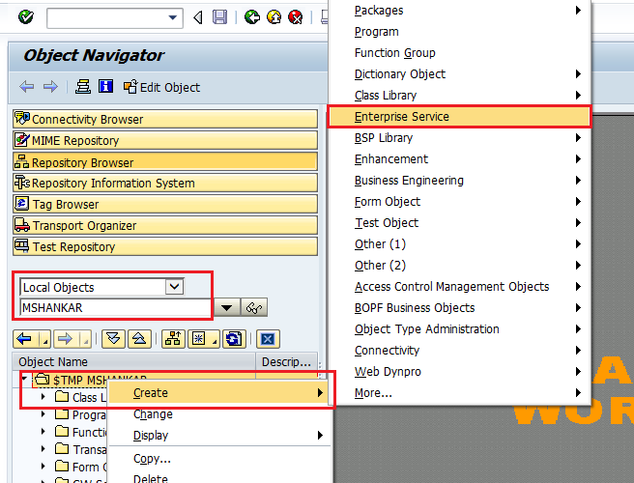

**Step 2:** Select Service Consumer 🡪 Select Service Consumer 🡪 Continue

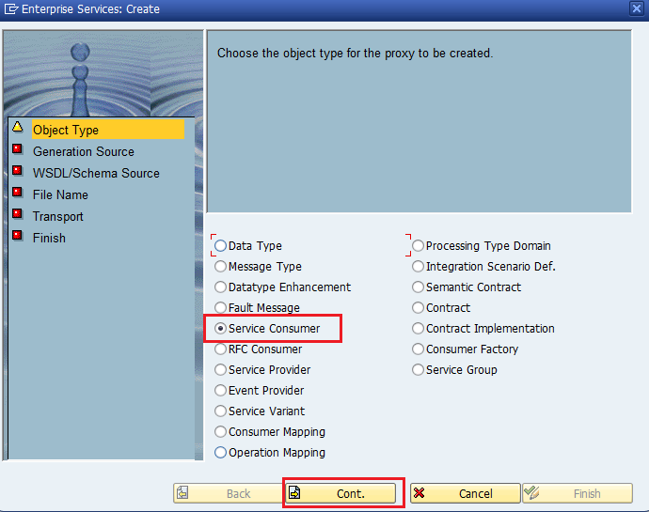

**Step 3:** Select External WSDL/Schema 🡪 Continue

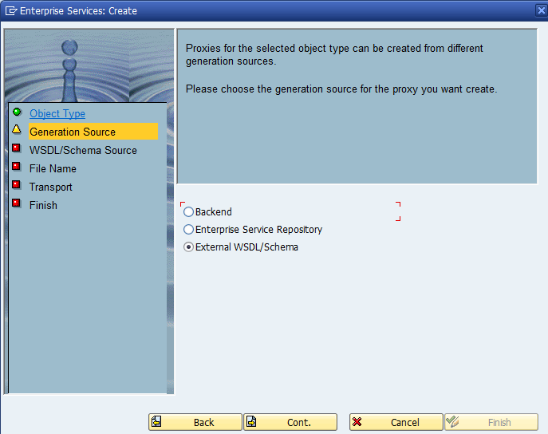

**Step 4:** Select Local File 🡪 Continue

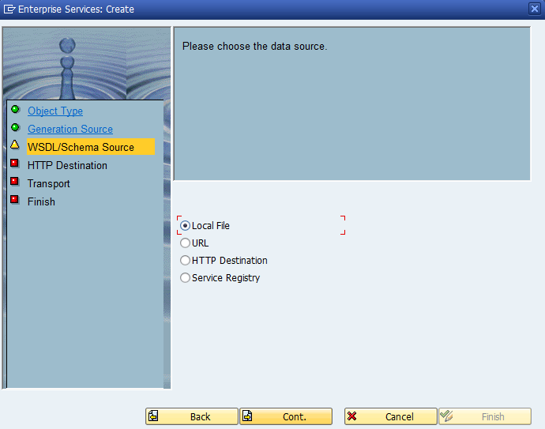

**Step 5:** Press F4 🡪 Select your file 🡪 Continue

*Order of content element in WSDL should be maintained in following order:*

1. *Types*
2. *Message*
3. *PortType*
4. *Binding*
5. *Service*

If contents are not in correct order as mentioned above, we’ll get error at the time of uploading WSDL file.

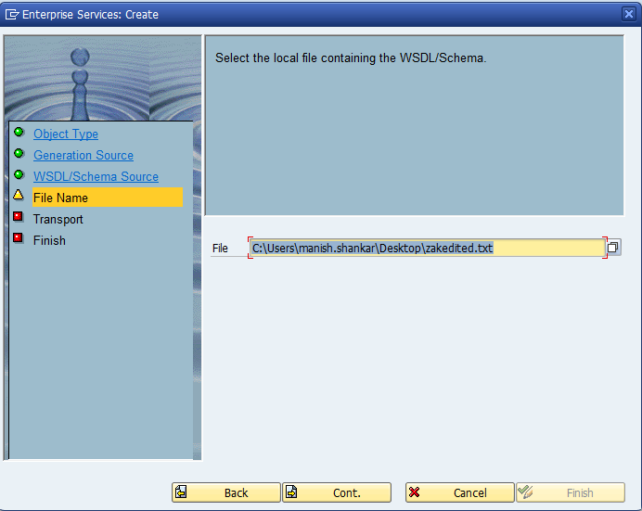

**Step 6:** Enter the Package name and TR. Enter *Prefix* starting with Y or Z as proxy classes will be created in Customer namespace 🡪 Continue

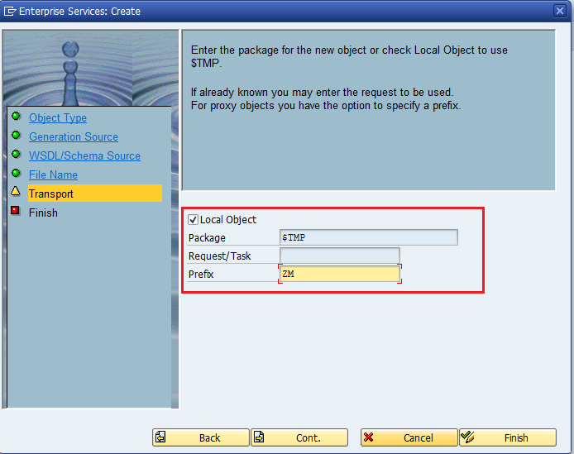

**Step 7:** Click on Complete

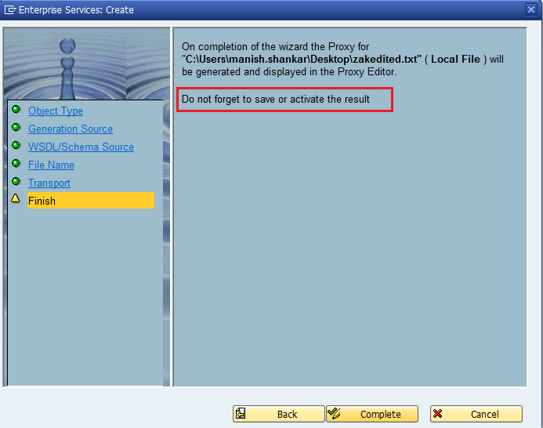

**Step 8:** After completing the above steps, below screen will appear 🡪 Save and Activate.

Highlighted ABAP Name is Generated Proxy Class: ZMCO_PORT_TYPE1

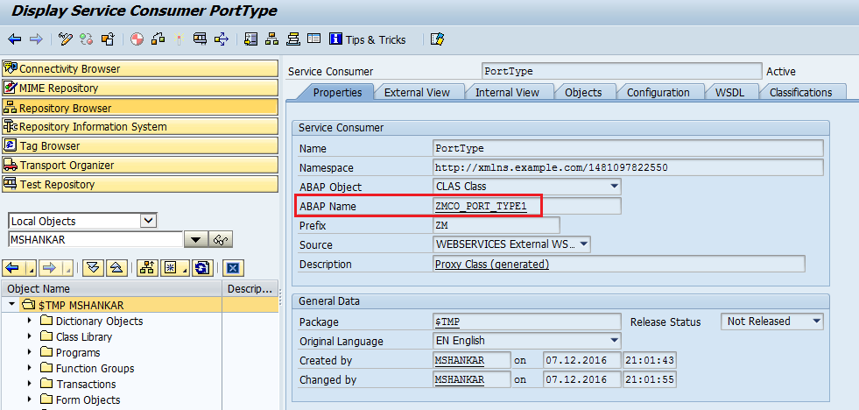

**Step 9:** Navigate to Class ZMCO_PORT_TYPE1 🡪 Check the Parameter of ‘OPERATION’ method

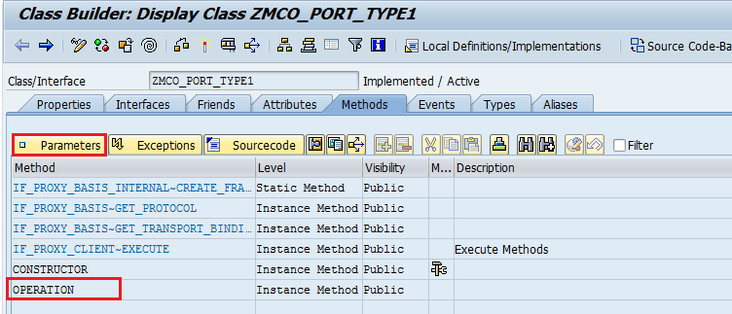

Input Parameter will take Input from SAP and if it pass the data to TIBCO, we’ll get the result in Output Parameter.

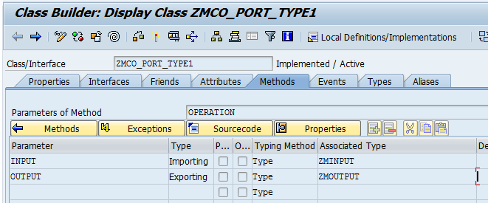

**Step 10:** Navigate to Tab ‘External View’ 🡪 Fault 🡪 ZMCX_FAULT is the generated Exception Class

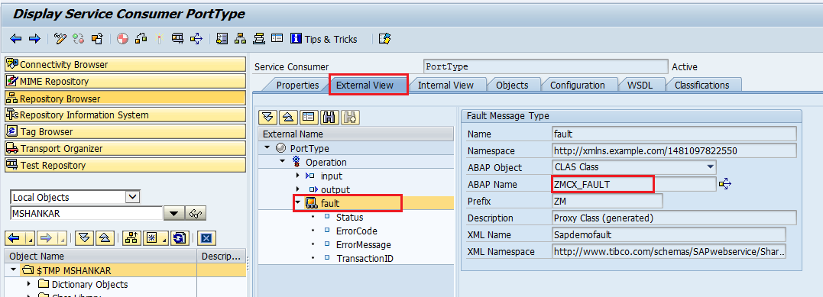

Navigate to ‘Objects’ tab to check the generated objects (Proxy Class, Exception Class & Structures)

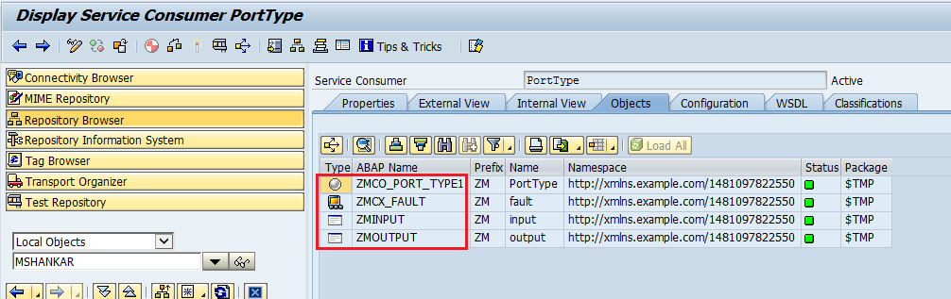

Now we have completed Service Consumer Creation Part.

**Now this Web Service should be configured in SOAMANAGER to publish it.**

***SOAMANAGER*** *Configuration should be done in Test Client.*

**Step 1:** GoTo TCode SOAMANAGER 🡪 it’ll be open in Internet Explorer 🡪 Below screen will appear 🡪 Click on Web Service Configuration

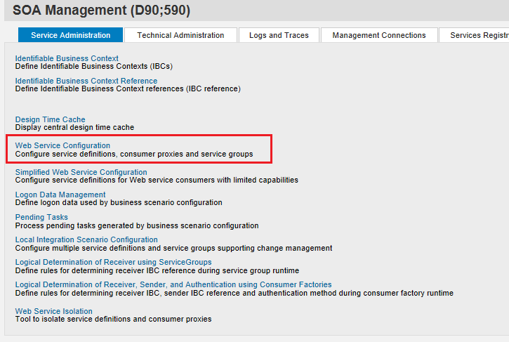

**Step 2:** Search here by Object Name: ‘*Generated Proxy Class Name: ZMCO_PORT_TYPE1’*

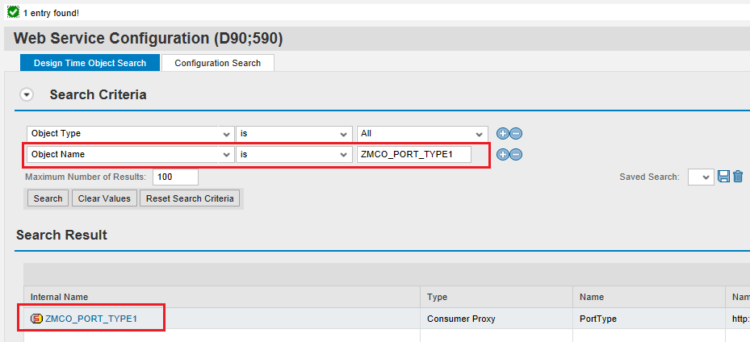

**Step 3:** Click on the Internal Name: ZMCO_PORT_TYPE1 🡪 you’ll get below screen

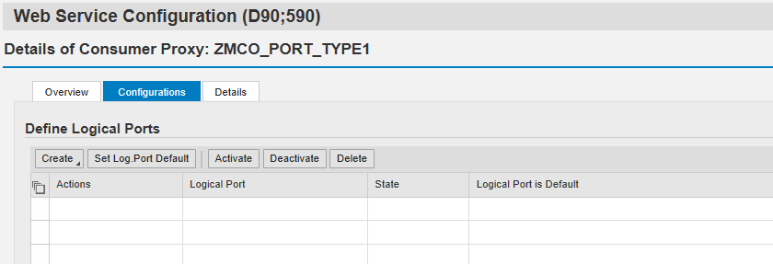

**Step 4:** Click on Create 🡪 WSDL Based Configuration

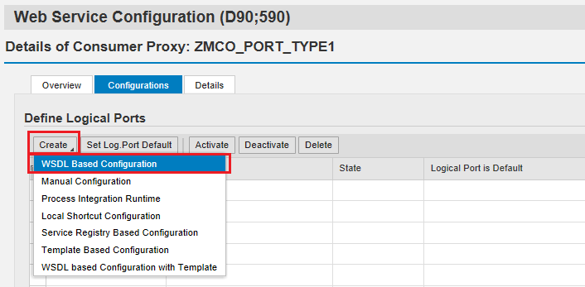

**Step 5:** Enter the Logical Port Name 🡪 Check the CheckBox for Default Logical Port 🡪 Next

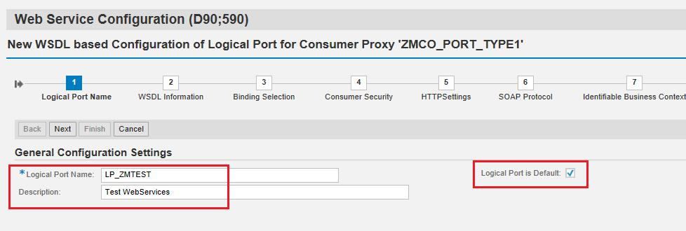

**Step 6:** Select WSDL Base: Via File 🡪 Browse the WSDL File 🡪 Next

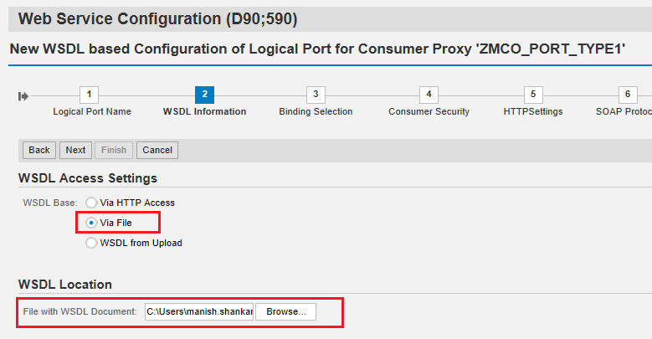

**Step 7:** Click on Next

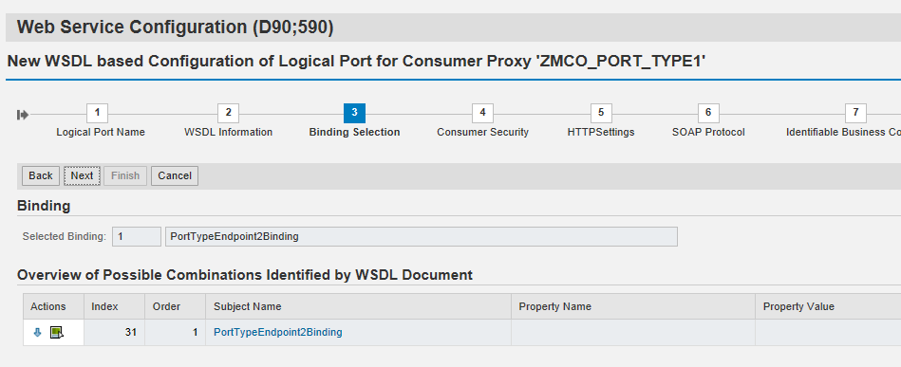

**Step 8:** Click on Next

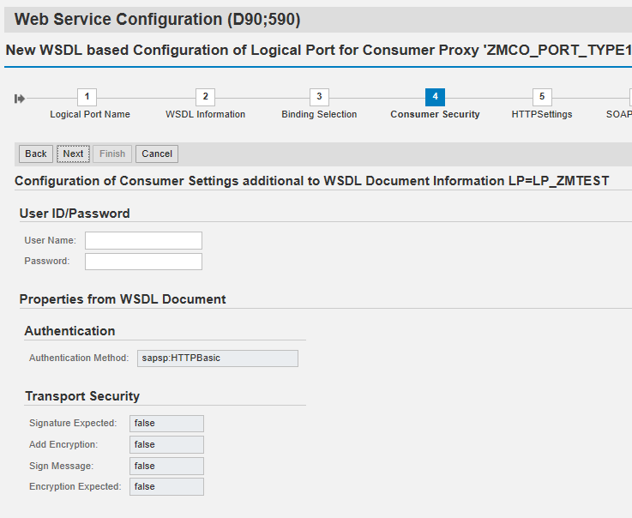

**Step 9:** Click on Next

Computer Name of Access URL and Port Number of Access URL will be provided by TIBCO.

Computer Name of Access URL: 10.140.102.82

Port Number of Access URL: 11555

To check this URL, we need to ask Basis if Telnet is happening to this IP and Port Number from our SAP server.

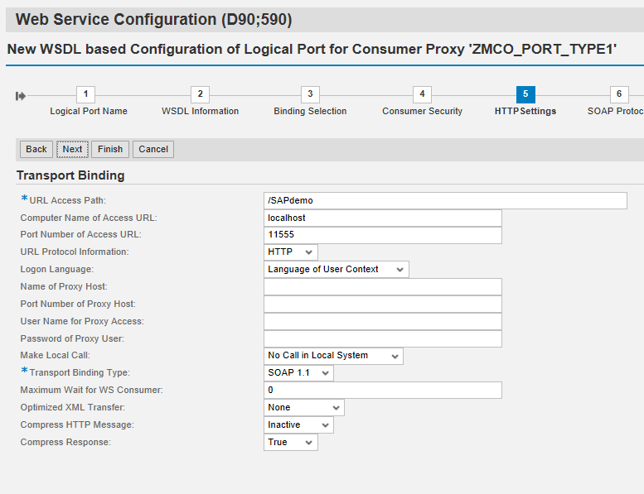

**Step 10:** Click on Next

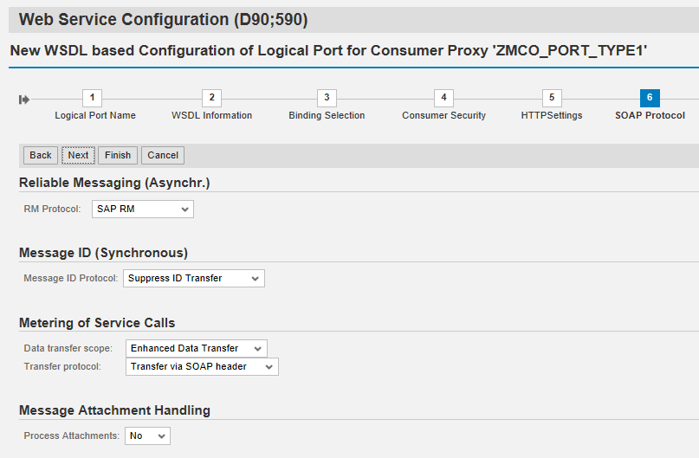

**Step 11:** Click on Next

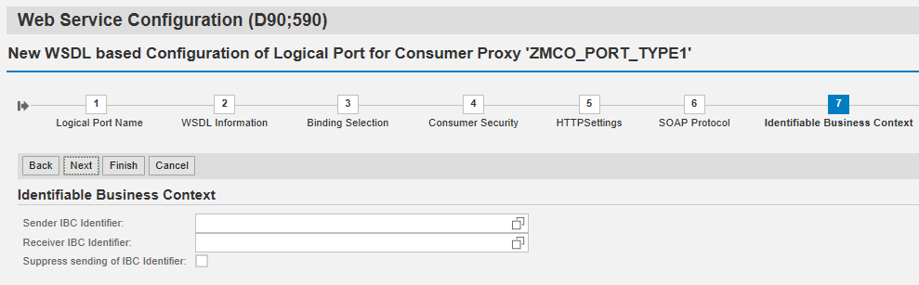

**Step 12:** Finish

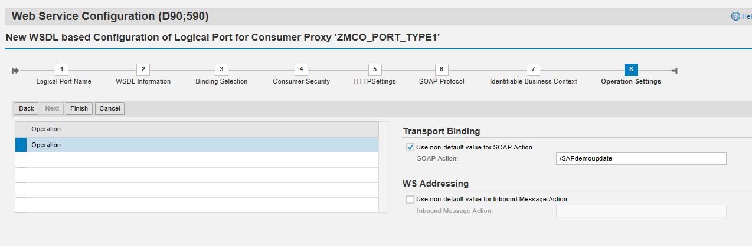

Now SOAMANAGER Configuration is over.

**Using Proxy Class in Program**

**Step 1:** Create Object for the Generated Proxy Class: ZMCO_PORT_TYPE1.

DATA : gr_send   TYPE REF TO zmco_port_type1.

  TRY.  
    CREATE OBJECT gr_send  
        EXPORTING  
         logical_port_name = space.  
  CATCH cx_ai_system_fault

 ENDTRY.

**Step 2:** Call the Method ‘OPERATION’ of Proxy Class: ZMCO_PORT_TYPE1

IF gr_send IS BOUND.  
          TRY.  
              CALL METHOD gr_send->operation  
                EXPORTING  
                  input  = gw_input  
                IMPORTING  
                  output = gw_output.  
  
            CATCH cx_ai_system_fault.  
  
            CATCH zmcx_fault .  
  
          ENDTRY.  
        ENDIF.

*Please check the Test FM: ZMTEST_WEBSERVICES in D90 Server.*

**Troubleshooting**

1. File contents should be in correct order:

Types

Message

PortType

Binding

Service

1. If TIBCO is not getting hit from Web Service, then get the IP and PORT from SOAMANAGER and check with Basis if Telnet is happening.
2. SOAP Action name should be same in SOAMANAGER and TIBCO. If TIBCO is not getting hit then check SOAP Action in both the system (SAP & TIBCO).

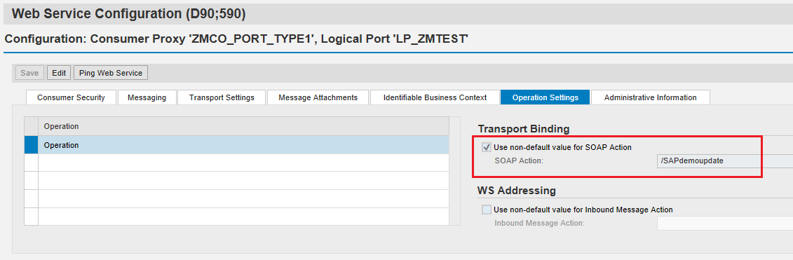

1. Web Service can be traced by using Web Service Utilities (TCode: SRT_UTIL)

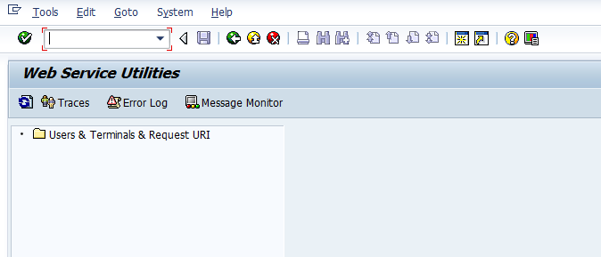

Click on Trace 🡪 Press Enter

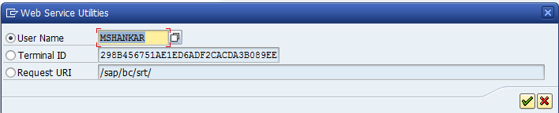

Enter the details 🡪 Save

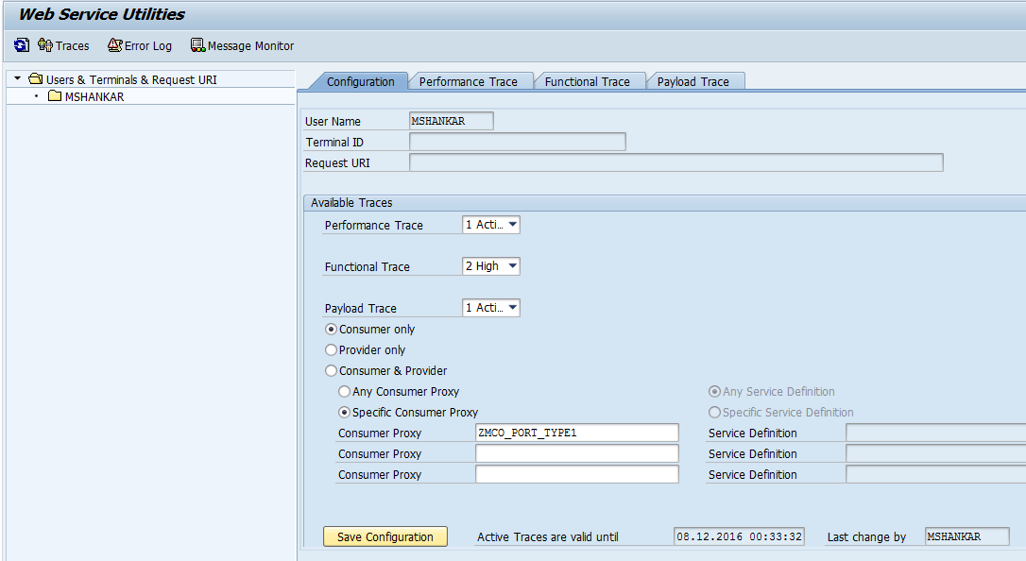

Execute the Program which is calling Web Service 🡪 In case of any issue, it can be traced by Clicking on ‘*Error Log’* button.

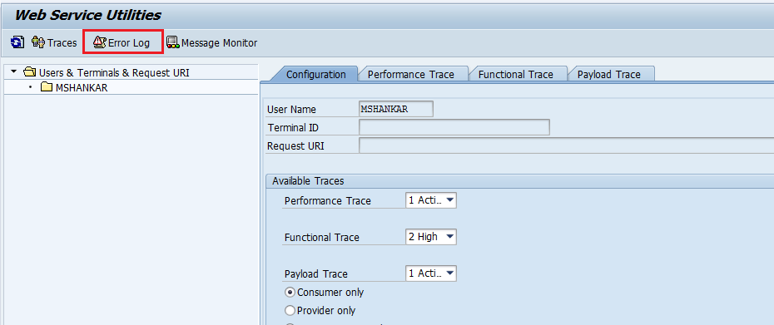

In Payload Trace tab, sending and receiving data can be traced.

